

# **UNIVERSITY OF KARACHI**

# **DEPARTMENT OF COMPUTER SCIENCE**

# **PROJECT REPORT: DATA WAREHOUSING AND DATA MINING**

# **ACADEMIC YEAR: 2020-2021**

# **MCS FINAL(MORNING)**

# **PROJECT TITLE: COVID19DATA ANALYSIS AND VISUALIZATION**

**GROUP MEMBERS:**

1. NumrahAlauddin P19101052
2. Saba Islam P19101059
3. Sheikh Muhammad ShayanIqbal P19101066
4. Amir Raza P19101006

**SUBMITTED TO**

**SIR TEHSEEN AHMED JILANI**

Table of Contents

**1.** **ABSTRACT** 3

**2.** **INTRODUCTION** 4

COVID-19 DATA ANALYSIS AND VISUALIZATION: 4

**3.** **LITERATURE REVIEW** 5

i. The Analysis of Spread of Corona Virus 6

ii.Comparison Table 6

iii.Comparison Of Death Ratio 8

**4.** **VISUALIZATION OF COVID-19 DATA** 9

**i.** **Covid-19 data** 10

**ii.** **Multilevel Table** 10

**iii.** **Describe data** 13

**iv.** **Summary of our data** 13

**5.** **CONFUSION MATRIX** 19

**Why you need Confusion matrix?** 19

**a)** **Outcomes of the confusion Matrix** 20

**b)** **Confusion Matrix Of Our C ovid-19 Data** 20

**c)** **Explanation** 22

**d)** **Accuracy Test** 22

**6.** **CONCLUSION** 22

**i.** **Impact of COVID-19 by Age** 22

Age is *not* just a number 23

**7.** **Appendix** 28

# **ABSTRACT**

Data-mining is one of the most hopeful and ever-changing field in the field of data analysis. The current paper reviews various papers published on COVID19 using data-mining methods to deal with this epidemic in terms of definition, testing and solution. The current document reviews the work done by a variety of authors using data-mining methods. The paper contributes specifically to the literature by filling the gaps in the review of work associated to COVID-19. The following page presents a brief overview of all the events that took place after the plague began. A brief review of SARS-CoV-2 attempted to be a summary of the paper provided. The idea of ​​working for SARS-CoV-2 to represent the effects of the epidemic around the world is how it changes people's behavior, lifestyle, and their perceptions of nature.

Keywords: COVID19, data-mining, reviews, epidemics, diseases.

# **INTRODUCTION**

## COVID-19 DATA ANALYSIS AND VISUALIZATION:

Since December 2019 the world has been plagued by a deadly virus caused by the novel corona virus called severe respirational syndrome corona virus 2 (SARS-CoV-2). The disease allied with this virus is known as COVID-19.

The COVID-19 outbreak was earliest reported in Wuhan, China and has spread to more than 50 countries. The WHO has declared COVID-19 as the International Emergency Medical Concern (PHEIC) on January 30, 2020. Naturally, a growing infectious disease involves the rapid spread, endangerment of many lives, and thus urgent action to prevent this disease. Social level. The lethal effect of COVID-19 is conducting a large number of studies aimed at understanding the various features of the epidemic. Although there is no vaccine, much effort has been put into understanding the spread of the infection in diverse parts of the world. The rate at which the virus has spread worldwide requires immediate solutions to understand and measure the progression of the disease.

According to the World Health Organization (2020), the 2019 coronavirus novel SARS-CoV-2 caused an epidemic of pneumonia in Wuhan, China, leading to the 2019-2020 corona virus pandemic announced by the World Health Organization (WHO). It belongs to the small family Orthocoronavirinae. It is different from Middle East Respiratory Syndrome (MERS) and the sterner Corona Virus (SARS-CoV). The study of Chen recommended that infected patients show clinical manifestation of dry cough, fever, confusion, sore throat, rhinorrhea, chest pain, dyspnea, Pneumonia is common in the brain, nausea, vomiting and diarrhea. The SARS-CoV-2 virus known as COVID-19 can be fatal. This occurs when the initial severity of the illness causes severe alveolar injury and progressive respiratory failure and a mortality rate of 2%.

On January-30-2020, the World Health Organization (WHO) declared the outbreak of COVID-19 as the sixth international public health emergency, following H1N1 (2009), polio (2014), Ebola in West Africa (2014), Zika (2016), and Ebola in the Democratic Republic of Congo (2019) (Yoo JH, 2020). Since the advent of COVID-19 and its impact on the continents of developing and developing countries, there have been numerous research documents published on various aspects of COVID-19. In addition to the research that is being done on immunization, drug treatment and other clinical aspects, much of the research work is being done with patients as well as fully recovered patients; patients associated with illness and viral event etc. A comprehensive analysis is being done on people recovering to determine how they can cope with these events. Data scientists around the globe are busy making sense of available data and predicting the near upcoming. Finding the pattern of trends, the selection of features, the prediction strategies used internally and externally to approach to a conclusion (Rajan Gupta, Saibal Kumar, 2020).

# **LITERATURE REVIEW**

Corona virus belongs to the family Coronaviridae according to the Nidovirales system. Corona represent crown-shaped spike on the exterior of the virus; therefore, it was named as corona virus. Corona viruses are small (65-125 nm in diameter) and contain single-stranded RNA as a nucleic, size ranging from 26 to 32kbs in length, as shown by the small corona virus family groups are alpha (α), beta (β), gamma (γ) and delta (δ) corona virus. Acute Respiratory Syndrome corona virus , H5N1 virus A, H1N1 2009 and Middle East Respiratory Syndrome Corona virus cause acute lung injury (ALI) and acute Respiratory Distress Syndrome (ARDS) leading to in lung failure and the result in death. These viruses were thought to infect only the animals in anticipation of the world saw the outbreak of a serious respiratory infection (SARS) caused by SARS-CoV, in 2002 in Guangdong, China (N. Zhong, B. Zheng, Y. Li, L. Poon, Z. Xie, K. Chan, et al, 2003).

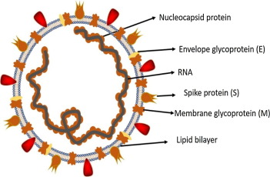Fig. 1

Historically, SARS-CoV (2003) diseased 8098 people with a death rate of 9%, in 26 countries around the world, on the other hand, the novel coronavirus (2019) infected 120,000 people with a death rate of 2.9%, in all 109. In countries, to date this writing. It shows that the SARS-CoV-2 transmission rate is higher than SRAS-CoV and the cause may be the event of genetic recombination of S protein in the RBD region of (SARS-CoV-2) is likely to improve its transmission capacity. In this review article, we briefly discuss the transmission of human coronaviruses. We also discussed diseases associated with the biological features of SARS and MERS with a specific focus on COVID-19.

## The Analysis of Spread of Corona Virus

The research analysis suggested that the cause and spread was significant to establish in order to develop infection avoidance strategies. In the case of SARS-COV, researchers initially all ears on raccoon dogs and palm civets as a last resort. (B. Kan, M. Wang, H. Jing, H. Xu, X. Jiang, M. Yan, et al, 2005).

However, a study by B.J. Zheng, Y. Guan, K.H. Wong, J. Zhou, K.L. Wong, B.W Young, et al in 2004 reported that only sample isolated from the civets of the food market showed positive effects of viral RNA recognition, suggesting that palms may be secondary hosts. In 2001 the samples were detached from healthy people in Hong Kong and molecular challenging showed a 2.5% antiretroviral rate against SARS-corona virus. These indicators suggest that SARS-coronavirus may be circulating in humans before the outbreak in 2003.

In addition, in 2018, Eltahir, et al, Later in Rhinolophus bats be also found to have antibodies in opposition to SARS-CoV that elevated bats as a source of viral replication. Middle East Respiratory Syndrome (MERS) coronavirus first appeared in 2012 in Saudi Arabia, MERS-coronavirus is also associated with beta-coronavirus and having camels as a zoonotic source or main host.

In a latest study by R. In 2020 it was discovered that MERS-coronavirus be also detected in bats in Pipistrellus and Perimyotis. Bat strains support the statement that they are not snakes but only bats can be significant ponds as showing in the comparison data table. 1.

### Comparison Table

| **Features** | **SARS-CoV** | **SARS-CoV-2** | **Year** |
| --- | --- | --- | --- |
| Emergence date | November 2002 | December 2019 | 2003, 2004, 2020 |
| Area of emergence | Guangdong, China | Wuhan, China |
| Date of fully controlled | July 2003 | Not controlled yet |
| Key hosts | Bat, palm civets and Raccoon dogs | Bat | 2011, 2020 |
| Number of countries infected | 26 | 109 | 2020 |
| Entry receptor in humans | ACE2 receptor | ACE2 receptor | 2020 |
| Sign and symptoms | fever, malaise, myalgia, headache, diarrhea, shivering, cough and shortness of breath | Cough, fever and shortness of breath | 2003,2020 |
| Disease caused | SARS, ARDS | SARS, COVID-19 | 2003, 2020 |
| Total infected patients | 8098 | 123882 | 2020 |
| Total recovered patients | 7322 | 67051 |
| Total died patients | 776 (9.6% mortality rate) | 4473 (3.61% mortality rate) |

### Comparison Of Death Ratio

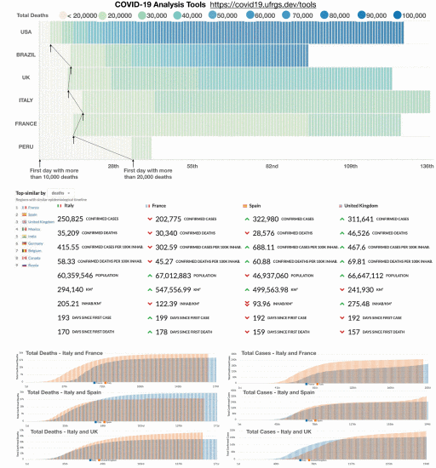

**Figure 2.**

**Description**: (Top) Heat map matriculates are helpful in comparing the time cycle as the mortality rate of different countries. Columns may be aligned on the first date after reaching a certain limit, which allows us to compare when countries pass certain test sites. (Below) Searches for locations with similar mortality rates in Italy.

A large group of community-developed dashboard and interactive tools for COVID-19 are available. The best places to start looking at a data hub hosted by the Tableau and the top 100 R resources structured by Soetewey. In addition, in-depth analysis is existing on sites, such as Our World in Data, Bing, and the COVID Tracking Project, among others. After developing the Brazilian console, we have dedicated our efforts to building a set of tools to variation the spread of COVID-19 data to different regions of the world. We have collected data from the website, and that observation has various charts that support multiple visualizations in a single diagram. Since the epidemic is located in different parts of the world, the article allows the user to align a time series of data with a specific data chain beyond a certain limit (e.g., after 100 cases). This illustration is useful for observation when unlike sites pass certain test sites taken from (covid19.ufrgs.dev).

# **Visualization of Covid 19 Data**

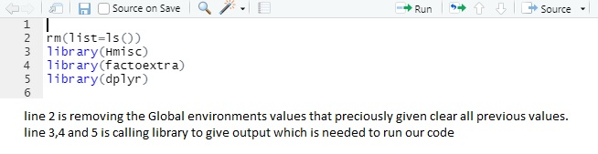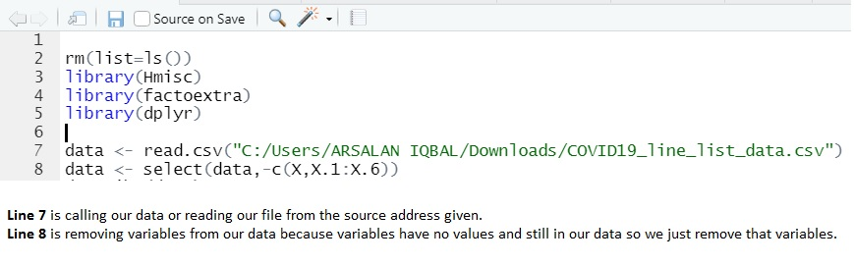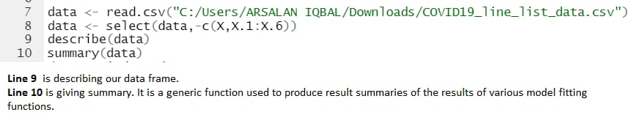

# **COVID-19 DATA:**

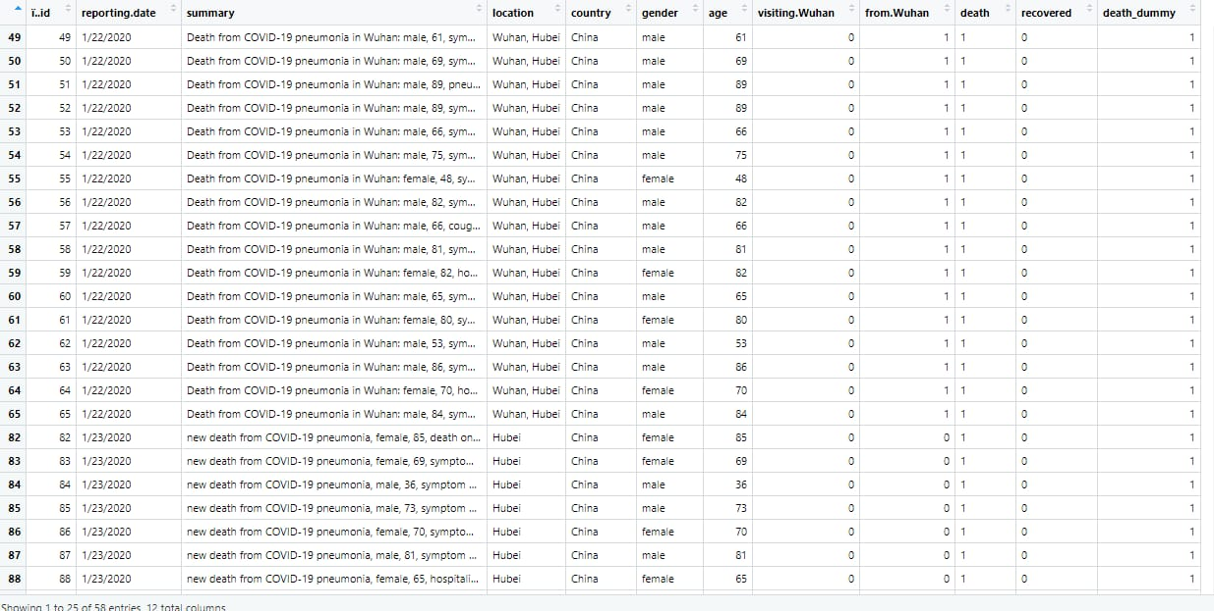

# **MULTILEVEL TABLE**

(Cases record from Starting first month 0f Covid-19)

|  |  |  |  |  |
| --- | --- | --- | --- | --- |
| COUNTRY | CITY | Total Cases | DEATH | RECOVERY |
| CHINA | Shenzhen, Guangdong | 1 | 0 | 1 |
| Shanghai | 2 | 0 | 2 |
| Zhejiang | 1 | 0 | 1 |
| Tianjin | 22 | 0 | 22 |
| Chongqing | 1 | 0 | 1 |
| Sichuan | 7 | 0 | 7 |
| Beijing | 18 | 0 | 18 |
| Shandong | 3 | 0 | 3 |
| Yunnan | 19 | 0 | 19 |
| Sichuan | 1 | 0 | 1 |
| Jiangxi | 3 | 0 | 3 |
| Macau | 4 | 0 | 4 |
| Liaoning | 4 | 0 | 4 |
| Fujian | 1 | 0 | 1 |
| Guizhou | 1 | 0 | 1 |
| Shanxi | 35 | 0 | 35 |
| Ningxia | 1 | 0 | 1 |
| Guangxi | 5 | 0 | 5 |
| Henan | 4 | 0 | 4 |
| Hebei | 1 | 0 | 1 |
| Jiangsu | 1 | 0 | 1 |
| Heilongjiang | 2 | 0 | 2 |
| Jilin | 2 | 0 | 2 |
| Wuhan | 40 | 39 | 1 |
| Hunan | 5 | 0 | 5 |
| Guizhou | 1 | 0 | 1 |
| Gansu | 1 | 0 | 1 |
| Xinjiang | 3 | 0 | 3 |
| Inner Mongolia | 1 | 0 | 1 |
| Hechi, Guangxi | 2 | 0 | 2 |
| Gansu | 2 | 0 | 2 |
| Ningxia | 1 | 0 | 1 |
| Guizhou | 1 | 0 | 1 |
| Jiangxi | 1 | 0 | 1 |
| AUSTRALIA | NSW | 4 | 0 | 4 |
| VICTORIA | 4 | 0 | 4 |
| QUEENSLAND | 5 | 0 | 5 |
| SOUTH AUSTRALIA | 2 | 0 | 2 |
| CAMBODIA | Preach Sihanouk | 1 | 0 | 1 |
| CANADA | TORONTO | 5 | 0 | 5 |
| VANCOUVER | 7 | 0 | 7 |
| FINLAND | LAPLAND | 1 | 0 | 1 |
| FRANCE | PARIS | 5 | 2 | 3 |
| BORDEAUX | 1 | 0 | 1 |
| ANNECY | 3 | 0 | 3 |
| AMIENS | 1 | 0 | 1 |
| STRASBOURG | 1 | 0 | 1 |
| NANTES | 1 | 0 | 1 |
| MONTPELLIER | 1 | 0 | 1 |
| BREST | 1 | 0 | 1 |
| LYON | 1 | 0 | 1 |
| NICE | 1 | 0 | 1 |
| GERMANY | BAVARIA | 5 | 0 | 5 |
| Baden-Wuerttemberg | 3 | 0 | 3 |
| Tubingen | 2 | 0 | 2 |
| North Rhine-Westphalia | 3 | 0 | 3 |
| HESSE | 1 | 0 | 1 |
| HONG KONG | KOWLOON | 4 | 1 | 3 |
| HONG KONG | 79 | 1 | 78 |
| FO TAN | 1 | 0 | 1 |
| Kwun Tong | 2 | 0 | 2 |
| Yau Ma Tei | 1 | 0 | 1 |
| Tsing Yi | 1 | 0 | 1 |
| Kwai Chung | 2 | 0 | 2 |
| Zhuhai | 1 | 0 | 1 |
| Wan Chai | 1 | 0 | 1 |
| Ngau Chi Wan | 1 | 0 | 1 |
| ITALY | ROME | 1 | 0 | 1 |
| JAPAN | JAPAN | 15 | 1 | 14 |
| TOKYO | 25 | 1 | 24 |
| Aichi Prefecture | 7 | 0 | 7 |
| Chiba Prefecture | 11 | 0 | 11 |
| Fukuoka Prefecture | 2 | 0 | 2 |
| Gifu Prefecture | 2 | 0 | 2 |
| Haneda | 1 | 0 | 1 |
| Hokkaido | 47 | 1 | 46 |
| Ishikawa | 5 | 0 | 5 |
| Kanagawa | 7 | 1 | 6 |
| Kumamoto City | 4 | 0 | 4 |
| Kumamoto Prefecture | 1 | 0 | 1 |
| Wakayama Prefecture | 12 | 0 | 12 |
| Sapporo | 5 | 0 | 5 |
| Sagamihara | 9 | 0 | 9 |
| Nara Prefecture | 2 | 0 | 2 |
| Nagoya City | 20 | 0 | 20 |
|  | Kyoto | 2 | 0 | 2 |
| Osaka Prefecture | 3 | 0 | 3 |
| Mie | 1 | 0 | 1 |
| Okinawa Prefecture | 3 | 0 | 3 |
| Nagano Prefecture | 1 | 0 | 1 |
| LEBANON | LEBANON | 1 | 0 | 1 |
| MALAYSIA | Johor | 8 | 0 | 8 |
| MALAYSIA | 14 | 0 | 14 |
| LAGKAWI | 1 | 0 | 1 |
| NEPAL | Kathmandu | 1 | 0 | 1 |
| PHILLIPINES | Manila | 2 | 1 | 1 |
| PHILLIPINES | 1 | 0 | 1 |
| SINGAPORE | SINGAPORE | 90 | 0 | 90 |
| SOUTH KOREA | SOUTH KOREA | 90 | 9 | 81 |
| SEOUL | 2 | 0 | 2 |
| SPAIN | Andalusia | 7 | 0 | 7 |
| Barcelona | 3 | 0 | 3 |
| Castellon | 1 | 0 | 1 |
| Castile and Leon | 1 | 0 | 1 |
| Tenerife | 1 | 0 | 1 |
| Valencia | 1 | 0 | 1 |
| Zaragoza | 1 | 0 | 1 |
| Sri Lanka | Sri Lanka | 1 | 0 | 1 |
| SWEDEN | Jonkoping | 1 | 0 | 1 |
| Switzerland | BERN | 1 | 0 | 1 |
| TAIWAN | TAIWAN | 31 | 1 | 30 |
| Thailand | Thailand | 16 | 0 | 16 |
| DUBAI | UAE | 7 | 0 | 7 |
| UK | LONDON | 1 | 0 | 1 |
| USA | Washington | 1 | 0 | 1 |
| Illinois | 2 | 0 | 2 |
| Massachusetts | 1 | 0 | 1 |
| California | 2 | 0 | 2 |
| Vietnam | Ho Chi Minh City | 2 | 0 | 2 |
| VinhPhuc | 6 | 0 | 6 |

# **DESCRIBE DATA:**

# 

# **SUMMARY OF DATA:**

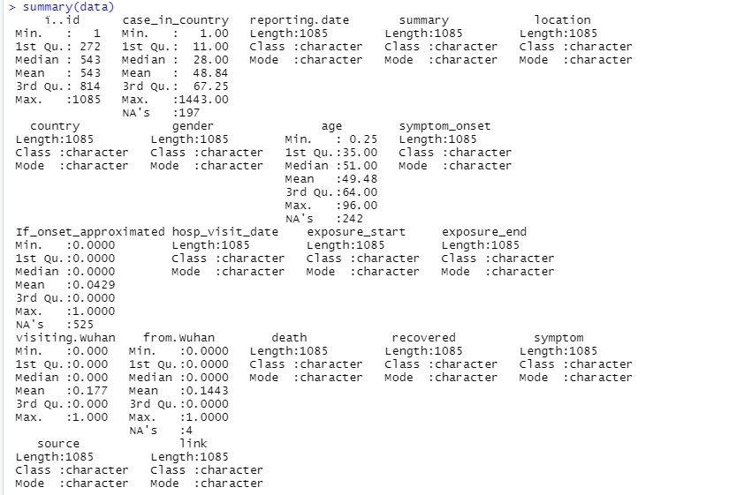

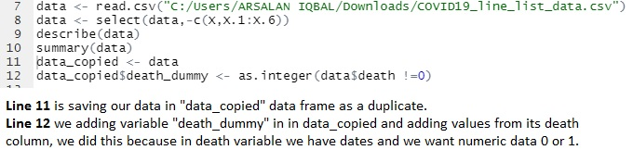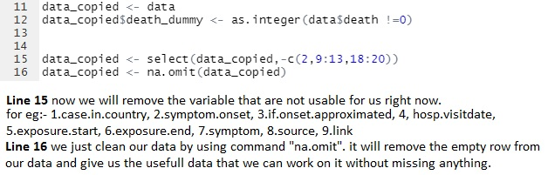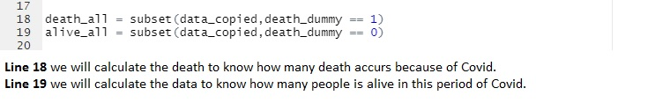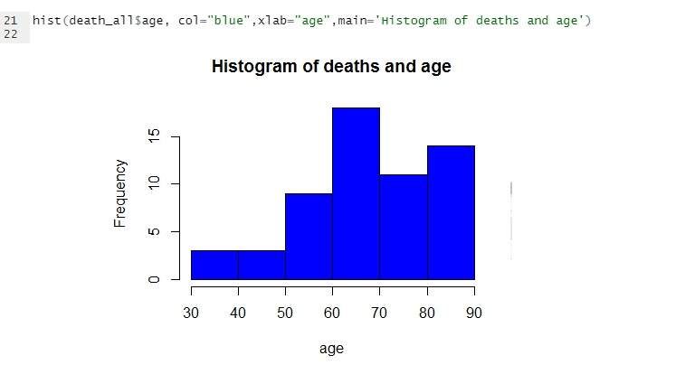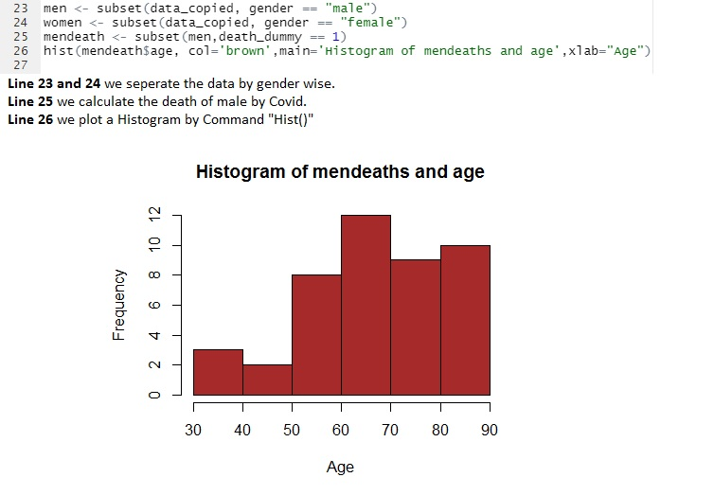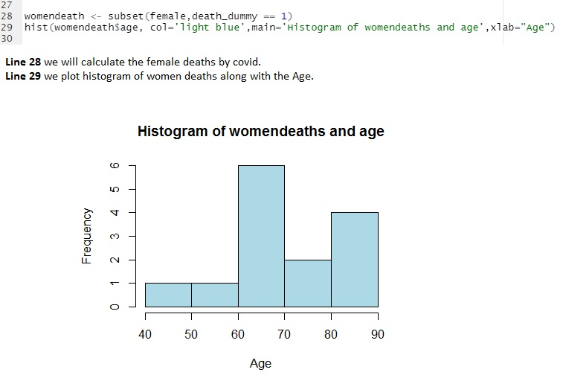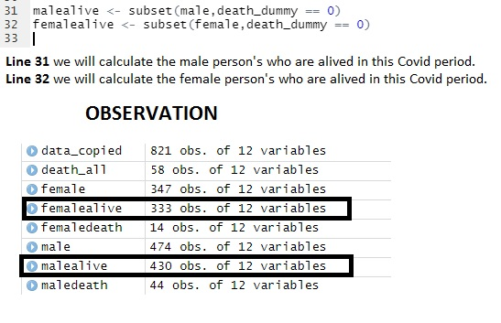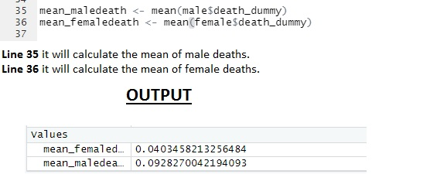

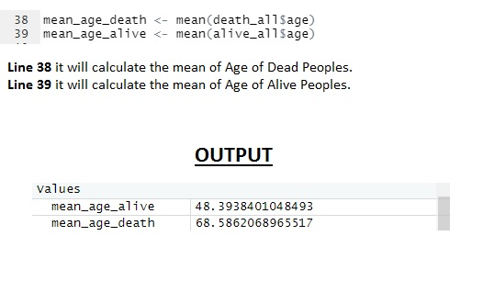

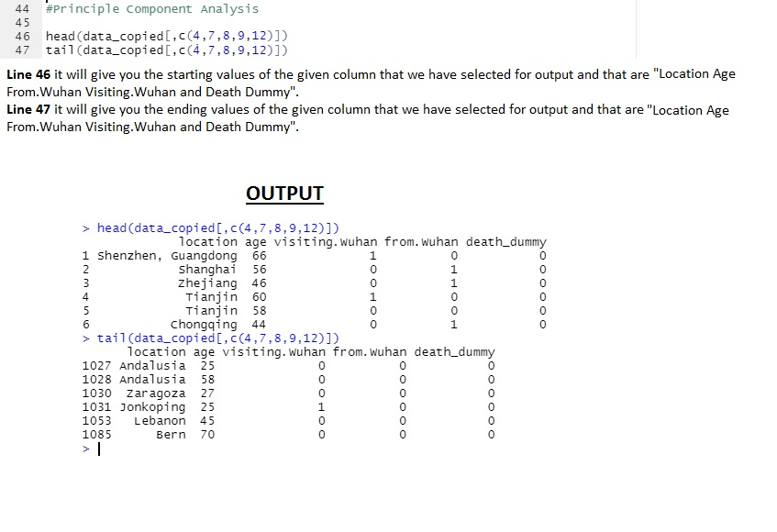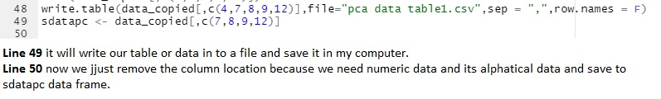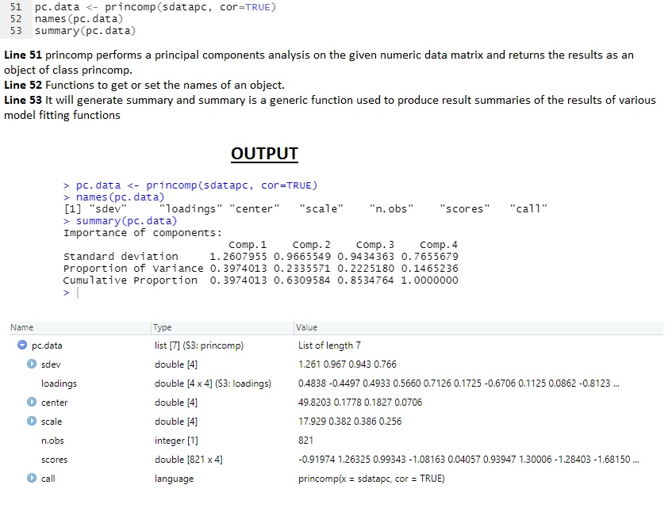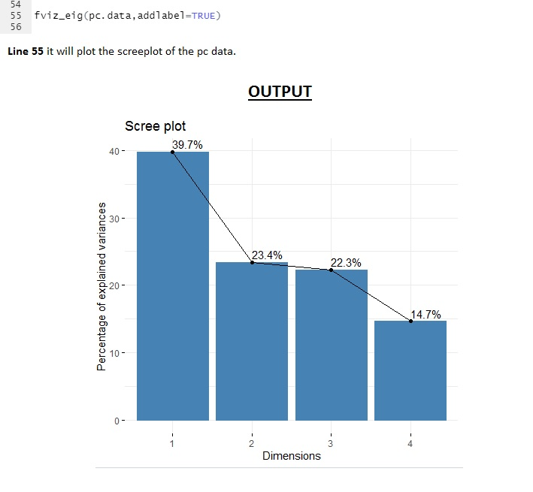

# **CONFUSION MATRIX**

The confusion matrix is ​​a technique of measure the performance of a learning machine. It is a type of table that helps you to know the functionality of the partition in the test data set so that the exact values ​​are acknowledged. In simple terms, “Confusion matrix is ​​a performance measure of machine learning algorithm”.

By visualizing the matrix of confusion, one can determine the accuracy of a model by looking at diagonal values ​​to estimate the value of precise separation.

# **Why you need Confusion matrix?**

* It represents how any discrimination model is confused when creating predictions.
* The confusion matrix not merely gives you a thought of ​​the mistakes that are made for your student but as well the sorts of mistakes that are set.
* This classification helps you to overcome the limit of using the accuracy of the sections themselves.
* Each column of the confusion matrix represent the conditions of the estimate phase.
* Each line of the matrix of confusion signifies the conditions of the real phase.
* It not only give insight into classified error but also errors.

# **OUTCOMES OF THE CONFUSION MATRIX**

The confusion matrix visualize the accurateness of a class divider by associating real and expected categories. The binary confusion matrix is ​​square:

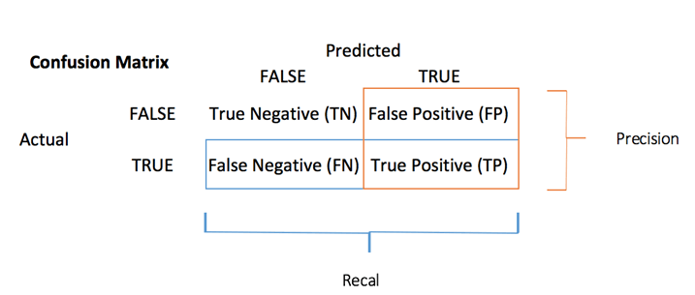

* TP: True Pos: Predicted values appropriately predicted as actual positive
* FP: Predicted values inaccurately predicted an actual positive. i.e., Negative values predicted as positive
* FN: False Neg: Positive values anticipated as negative
* TN: True Neg: Predicted values appropriately predicted as an actual negative

# **CONFUSION MATRIX OF OUR COVID-19 DATA**

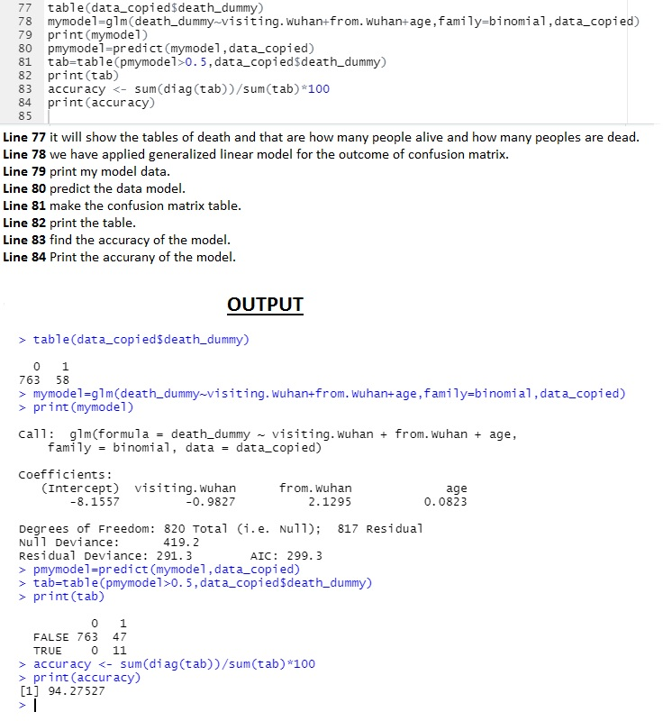

# **Explanation**

The output shows the values of confusion table as:

* TN: True Negative = 763, i.e. these patients predicted as they will not die and they actually not died.
* FP: False Positive =47, i.e. these patients predicted as they will die but they did not.
* FN: False Negative =0, i.e. these patients predicted as they will not die but they died.
* TP: True Positive =11, i.e. these patients predicted as they will die and they actually died.

# **ACCURACY TEST**

# One of the most important parameters in determining the accuracy of division problems, is how the model usually predicts the correct output and can be measured as the number of true predictions made by the classifier over the total number of calculations made by classifier.

Calculated accuracy from the confusion matrix with the following formula:

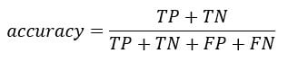

The output shows the accuracy test result as **94.27,** which shows that our model predicts output 94% correctly which is the high ratio and good for our further data mining analysis.

# **Conclusion**

# COVID-19 is spreading rapidly around the world. Within a few months, the mortality and morbidity levels reached an unexpected level. Doctors are working to develop treatments and vaccines to prevent the spread of the disease. A terrible situation is yet to come. However, if we take just one step of isolation, it can save the whole community and the risk will decrease dramatically. This is a situation where each person should take steps to reduce the risk by staying indoors and taking personal action. Transmission, the contact can be disinfected only if proper hand washing procedures are followed and individuals take precautionary measures to protect other people from the invading virus. The world has great potential for public health, and the various sectors can work together to address the challenges of public-private partnerships and policy initiatives.

# **Impact of COVID-19 by Age**

This study aims to integrate existing research into the effects of the COVID-19 epidemic, as well as related interventions for isolation and prevention strategies, in adults. The second objective is to investigate the effects of the COVID-19 epidemic, as well as the associated measures of isolation and prevention measures, in older adults with Alzheimer's disease and related dementia.

## While COVID-19, an infection cause by the new corona-virus, can lead to hospitalization and even death in young and middleaged adults, create more serious health troubles for adults over the age of 60 - with deadly consequences especially for those 80 year and older. This is due to the low level of health conditions that exist in older people. Conditions such as diabetes, heart disease, and other chronic illness may direct to severe symptom and complication. Moreover, as people get older, their immune system slowly loses its strength, which means they are at risk of infection of any kind, mainly new ones similar to COVID-19.

## Adults are apparently among the groups most at risk of illness and death for COVID-19. Data from China after the first few months of the Wuhan outbreak highlighted the risk of serious illness and death of COVID-19 in the elderly, with a mortality rate of nearly 15 percent in people aged 80 and older, compared with a total of 2.3 percent in the general population.

## Age is notjust a number

Older adults are the main victims of the COVID19 novel outbreak and older people in Long Term Care Facilities (LTCFs) are particularly vulnerable to death. This Report presents a qualitative study of the impact of the COVID19 outbreaks in Wuhan during the early stages of the epidemic, which focuses on the effects of increased mortality among older people over the age of 80 and its relationship to LTCFs. The study of growth patterns shows an increase in legal status in the early stages of the epidemic through unequal behavior between different regions and an increase in deaths due to the different effects of COVID-19. However, the incidence rate of COVID-19 does not fully explain the effect of the impact on adult mortality among different regions. We explain the volume correlation between adult mortality and the number of people on LTCFs confirming the significant impact of COVID-19 on LTCFs. Adding a link between LTCFs and undiagnosed conditions as well as the effects of health system malfunctions is also being observed. Our results confirm that LTCFs did not play a protective role for older adults during the epidemic, but when the number of older people living on LTCFs increased the number of common and COVID19-related deaths. We also observed that problem management in LTCFs disrupted the tracking of COVID19 prevalence and promoted an increase in deaths not directly caused by SARS-CoV2.

While we ought to be extremely careful in dividing the age when it comes to determining who needs serious care by providing services to young people and not the elderly it is obviously the most important factor in predicting the chances of survival of COVID-19. In fact, this is one of the strongest consensuses among scientists. In a good country, that alone should defend the expectation that older people will be more effective in following community health recommendation. However, the issue is not so clear-cut.

COVID-19 is not the only disease known to have serious side effects in the elderly. This is a complication of pneumococcal infection or fever, among others. In both cases, there are defensive measures available.

That being said, the mortality rate of COVID-19 among the elderly is, in fact, much elevated than other diseases such as pneumococcal infection or fever. In addition, the response of government and general public and the measures taken to reduce the effects of the disease are to a completely different degree. Therefore, it is only reasonable to suppose that older people will be more effective when it comes to follow the recommendations of civic health institutions and the government. The following graph shows the death rate by age group.

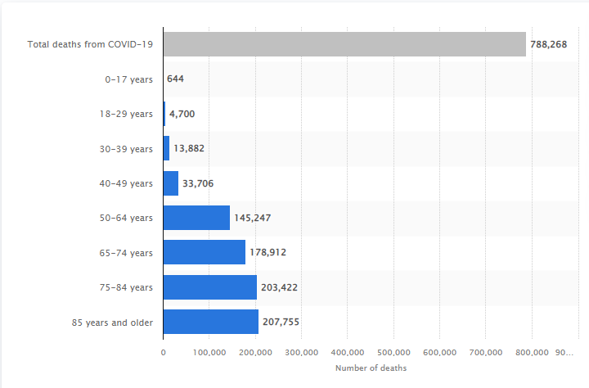

**References**

A. Soetewey, "Top 100 R resources on novel COVID-19 coronavirus", [online] Available: https://www.statsandr.com/blog/top-r-resources-on-covid-19-coronavirus.

B. Kan, M. Wang, H. Jing, H. Xu, X. Jiang, M. Yan, *et al.* **Molecular evolution analysis and geographic investigation of severe acute respiratory syndrome coronavirus-like virus in palm civets at an animal market and on farms.** J Virol, 79 (18) (2005), pp. 11892-11900

B.J. Zheng, Y. Guan, K.H. Wong, J. Zhou, K.L. Wong, B.W.Y. Young, *et al.* **SARS-related virus predating SARS outbreak, Hong Kong** Emerg Infect Dis, 10 (2) (2004), p. 176

C. Huang, Y. Wang, X. Li, L. Ren, J. Zhao, Y. Hu, *et al.* **Clinical features of patients infected with 2019 novel coronavirus in Wuhan China.** The Lancet (2020)

C. Paden, M. Yusof, Z. Al Hammadi, K. Queen, Y. Tao, Y. Eltahir, *et al.* **Zoonotic origin and transmission of Middle East respiratory syndrome coronavirus in the UAE.** Zoonoses Public Health, 65 (3) (2018), pp. 322-333

Chen N, Zhou M, Dong X, Qu J, Gong F, Han Y, Yu T. Epidemiological and clinical characteristics of 99 cases of 2019 novel coronavirus pneumonia in Wuhan, China: A descriptive study. The Lancet. 2020; 395(10223):507-513.

Dey SK, Rahman MM, Siddiqi UR, Howlader A. Analysing the Epidemiological Outbreak of COVID‐19: A Visual Exploratory Data Analysis (EDA) Approach. Journal of Medical Virology; 2020.

F. Pontes, F. Pinto, W. Leuschner and J. L. D. Comba, "COVID-19 analysis tools at Instituto de Informática-ufrgs", [online] Available: https://covid19.ufrgs.dev

Hui DS, I Azhar E, Madani TA, Ntoumi F, Kock R, Dar O, et al. The continuing 2019-nCoV epidemic threat of novel coronaviruses to global health—The latest 2019 novel coronavirus outbreak in Wuhan, China. International Journal of Infectious Diseases.2020; 91:264–6.

J.F.-W. Chan, S. Yuan, K.-H. Kok, K.K.-W. To, H. Chu, J. Yang, *et al.* **A familial cluster of pneumonia associated with the 2019 novel coronavirus indicating person-to-person transmission: a study of a family cluster.** Lancet (2020).

N. Zhong, B. Zheng, Y. Li, L. Poon, Z. Xie, K. Chan, *et al.* **Epidemiology and cause of severe acute respiratory syndrome (SARS) in Guangdong, People's Republic of China, in February, 2003.** The Lancet, 362 (9393) (2003), pp. 1353-1358

R. Lu, X. Zhao, J. Li, P. Niu, B. Yang, H. Wu, *et al.* **Genomic characterisation and epidemiology of 2019 novel coronavirus: implications for virus origins and receptor binding.** The Lancet (2020)

Rajan Gupta, Saibal Kumar. Trend Analysis and Forecasting of COVID-19 outbreak in India.Rajan Gupta, Saibal Kumar PalmedRxiv, 2020.

Sohrabi C, Alsafi Z, O’Neill N, Khan M, Kerwan A, Al-Jabir A, Agha R. World Health Organization declares global emergency: A review of the 2019 novel coronavirus (COVID-19). International Journal of Surgery; 2020.

Tian X, Li C, Huang A, Xia S, Lu S, Shi Z, et al. Potent binding of 2019 novel coronavirus spike protein by a SARS coronavirus-specific human monoclonal antibody. bioRxiv; 2020.

Vara V. Coronavirus outbreak: The countries affected. 11 MARCH 2020; Available from: https://www.pharmaceutical-technology.com/features/coronavirus-outbreak-the-countries-affected/.

Yoo JH. The fight against the 2019‐nCoV outbreak: an arduous march has just begun. *J Korean Med Sci*. 2020;35: e56 10.

# **Appendix**

**Code:**

rm(list=ls())

library(Hmisc)

library(factoextra)

library(dplyr)

data<- read.csv("C:/Users/ARSALAN IQBAL/Downloads/COVID19_line_list_data.csv")

data<- select(data,-c(X.1:X.6))

data<- select(data,-c(X))

describe (data)

summary (data)

data_copied<- data

data_copied$death_dummy<- as.integer(data$death !=0)

data_copied<- select (data_copied,-c(2,9,10,11,12,13,18,19))

data_copied<- na.omit(data_copied)

death_all = subset (data_copied,death_dummy == 1)

alive_all = subset (data_copied,death_dummy == 0)

hist(death_all$age)

men<- subset(data_copied, gender == "male")

women<- subset(data_copied, gender == "female")

mendeath<- subset(men,death_dummy == 1)

womendeath<- subset(women,death_dummy == 1)

menalive<- subset(men,death_dummy == 0)

womenalive<- subset(women,death_dummy == 0)

mean_mendeath<- mean (men$death_dummy)

mean_womendeath<- mean (women$death_dummy)

mean_age_death<- mean (death_all$age)

mean_age_alive<- mean (alive_all$age)

hist(mendeath$age, col='brown')

hist(womendeath$age, col='light blue')

t.test(alive_all$age, death_all$age, alternative="two.sided", conf.level = 0.95)

t.test(men$death_dummy, women$death_dummy, alternative="two.sided", conf.level = 0.99)

#Principle Component Analysis

head (data_copied)

data_copiedpc<- data_copied[,c(7,8,9)]

pc.data<- princomp(data_copiedpc, cor = TRUE)

names (pc.data)

summary (pc.data)

eigenvectors<- pc.data$loadings

eigenvalues<- pc.data$sdev *pc.data$sdev

screeplot(pc.data,type="l", main="screeplot for the covid data")

abline(1,0,col= 'red',lty=2)

#REGRESSION

plot (data_copied$age,data_copied$death_dummy)

#CLUSTERING

data_ultra<- select(data_copied,-c(1,2,3,4,5,6,10,11,12))

data_ultra<- na.omit(data_ultra)

km<- kmeans(data_ultra, centers = 5, nstart = 100)

fviz_cluster(km, data = data_ultra)